Chapter 18, Solution 4.

Find the Fourier transform of the waveform shown in Fig. 18.29.

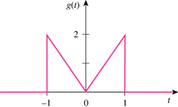

Figure 18.29
For Prob. 18.4.

Solution

We can solve the problem by following the approach demonstrated in Example 18.5.

t

0

2

g’
–2

–1

2δ(t+1)

–2δ(t–1)

1

t

0

4δ(t)

g”
–2

–1

2δ’(t+1)

–2δ(t–1)

1

–2δ(t+1)

–2δ’(t–1)

